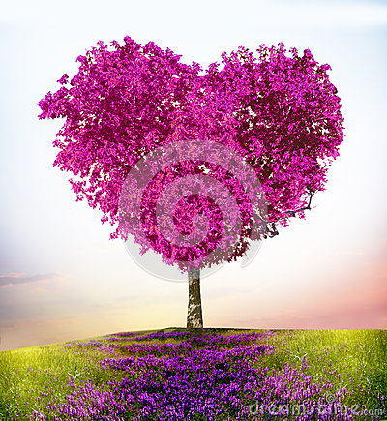

**Heart Powered**  **Manifesting**

By Josie Wood

**The 8 Heart Powered Keys**

**to Easily Create Your Most Fulfilling,**

**Successful and Happy Life**