**Everything The City Wants You To Know About The Rail**

**Lance Luke and Atticus Luke**

Copyright © 2016 Lance Luke

www.RailRipoff.com

All rights reserved.

ISBN: 6461018

ISBN-13: 978-1535588782

DEDICATION

Dedicated to

Mayor of Honolulu.

Honolulu City Council,

HART

ACKNOWLEDGMENTS

www.RailRipoff.com

www.RailRipoff.com

*

*

Aloha and welcome to RailRipoff.com. Before I go any further, I want to let you know that I am not anti-rail. I am not against the rail. I am for the rail. I voted for the rail but much later realized that I voted based on false information, like:  
1. The rail project would cost $5.29 billion (and no mention of GET funding)  
2. The rail project would go 20 miles to Ala Moana and have 21 rail stations.  
3. The rail project would be built on time.  
4. The rail project would create 10,000 local jobs.  
5. The rail ridership numbers were grossly inflated.

The cost of the rail project was poorly estimated from the start, and has been severely mismanaged. There has been very little accountability and to this day of August 8, 2016, HART refuses to provide much needed answers even to the Honolulu City Council, various members of the Legislature, and even to the FTA.

Even after not one, but two separate audits, there is still no transparency. The People of Hawaii deserve real and complete answers, and deserve to be told the true facts. We do not appreciate being told nothing. And when there is something to be told, we do not appreciate half-truths, twisted information, PR, white lies and smoke and mirrors.  
There is a huge difference between having a plan, and having the money to complete that plan. Right now there is no Recovery Plan, there is no money to go to Ala Moana, there are no real estate developers committed to buy a rail station and there is no total cost estimate. There is also no extension of the GET to help fund the rail. HART is broke and there are no funds to pay for the project to Ala Moana..

There are many hard working individuals working at HART, the City and various architects, engineers, consultants, construction workers etc. Some of them are my friends. Some of the contents of RailRipoff.com is by no means meant to devalue their services., or cut them down.

RailRipoff.com was created to discover the truth, report the facts, ask hard questions, and provide opinions. Our goal is to separate fact from fiction. The HART website does not tell all. It only contains information that they want the public to know.

RailRipoff.com is backed by a consortium of community leaders, construction industry experts, Hawaii taxpayers and concerned citizens not only in Hawaii but on the mainland and even around the world.  
Our Advisory Board consists of former and current politicians, contractors, construction workers, architects, engineers, cost engineers, CPA’s consultants, government workers and non-construction industry related concerned citizens.

If any of the information posted on RailRipoff.com is not accurate, I welcome any and all responses by HART, and will post HART’s response on RailRipoff.com. Furthermore, I have posed questions directly to HART and request answers to those questions. HART’s answers to my questions will also be posted on RailRipoff.com.

Stay tuned for the rest of the story: The Real Rail Book.

Mahalo, Be Informed and Happy Reading at RailRipoff.com.

Lance Luke

www.RailRipoff.com

*

www.RailRipoff.com

*

www.RailRipoff.com

*

www.RailRipoff.com

*

www.RailRipoff.com

*

www.RailRipoff.com

*

www.RailRipoff.com

*

www.RailRipoff.com

*

www.RailRipoff.com

*

www.RailRipoff.com

*

www.RailRipoff.com

*

www.RailRipoff.com

*

www.RailRipoff.com

*

www.RailRipoff.com

*

www.RailRipoff.com

*

www.RailRipoff.com

*

www.RailRipoff.com

*

www.RailRipoff.com

*

www.RailRipoff.com

*

www.RailRipoff.com

*

www.RailRipoff.com

*

www.RailRipoff.com

*

www.RailRipoff.com

*

www.RailRipoff.com

*

www.RailRipoff.com

*

www.RailRipoff.com

*

www.RailRipoff.com

*

www.RailRipoff.com

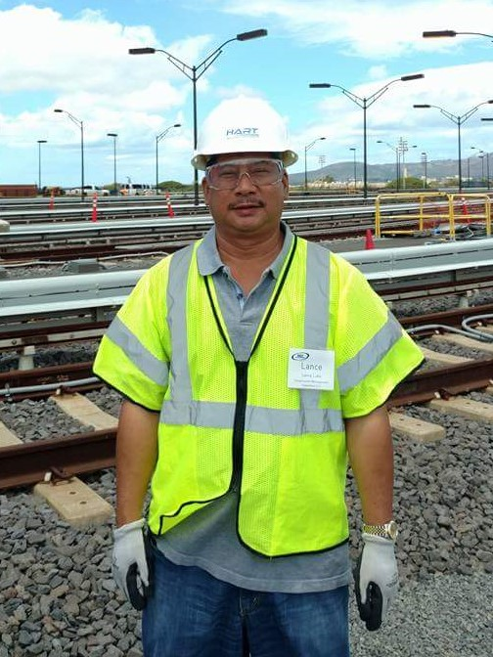

ABOUT THE AUTHOR

Lance Luke has been in the construction industry for over 36 years. He is a former general contractor and worked as a construction and project manager for real estate development and construction management/engineering companies. Currently he owns an independent construction management company. He has experience in design, home inspections, construction inspections, construction management, reserve studies and real estate development. His specialty is in inspection and construction management for condo association buildings and commercial properties. Recent types of projects worked on include structural concrete spalling repair, painting, roofing, waterproofing, asphalt resurfacing, plumbing re-piping, electrical retrofit and structural wood repair. He provides construction oversight and progress inspections for residential and commercial projects.

Mr. Luke holds a Bachelor’s of Science degree in Civil Engineering, and Masters and Doctorate degrees in Building and Construction Management. He has held the following designations for many years:

CCI - Certified Construction Inspector

CCPM - Certified Construction Project Manager

CCC - Certified Construction Consultant

CBI - Certified Building Inspector

Lance Luke serves as an expert witness on construction and real estate litigation cases. He is an Advisory Board Member for the State of Hawaii Regulated Industries Complaints Office, as an expert consultant. His expertise is helping to resolve construction complaints filed with the State of Hawaii Contractors’ License Board.

He has written numerous articles on construction and inspection, which have been published in both local and national print media. He is a highly sought after speaker, and presents up to ten Hawaii and national seminars a year to the construction, real estate and property management industry. He also is a presenter of national educational seminars and webinars.

Mr. Luke is a Best Selling Author and has been featured on national television on ABC, CBS, NBC and FOX Affiliates around the country.

Mr. Luke is a qualified insurance inspector for Research Specialist Inc., and an approved Federal HUD Construction Inspector. He is also listed as one of America’s Premier Experts and Marquis Who’s Who in America 70th Anniversary Edition. Lance is also a volunteer SCORE mentor providing consultation to business owners, and a Boy Scout Eagle Scout Advisor and Merit Badge Counselor (26 years). Lance Luke is also a performing and studio musician, music arranger, recording artist and music and video producer.

Lance Luke is a former member of the Structural Engineers Association of Hawaii and the American Bar Association and served on the Real Property/Probate Law Division and the Forum for the Construction Industry. He is a member of the American Association of Cost Engineers. He is or was a former member of the following Professional Associations:

* Construction Management Association of America (CMAA)
* The Construction Specifications Institute (CSI)
* Hawaii Building Association (HBA)
* International Code Council (ICC)
* International Concrete Repair Institute (ICRI)
* National Institute of Building Sciences (NIBS)
* Roofing Consultant’s Institute (RCI)
* Structural Engineers Association of Hawaii (SEAH)

Connect with Lance:

[LanceLuke@HawaiiBuildingExpert.com](mailto:LanceLuke@HawaiiBuildingExpert.com)

[www.hawaiibuildingexpert.com](http://www.hawaiibuildingexpert.com)

www.lanceluke.com

 (808) 422-2132

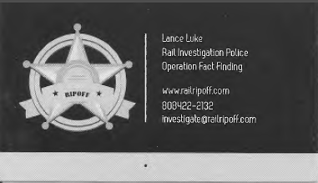

www.RailRipoff.com